My Journey
Elementary Symbol-Supported IEP & Access Toolkit
Communication first • multi-grade • ages 11–21 where developmentally appropriate
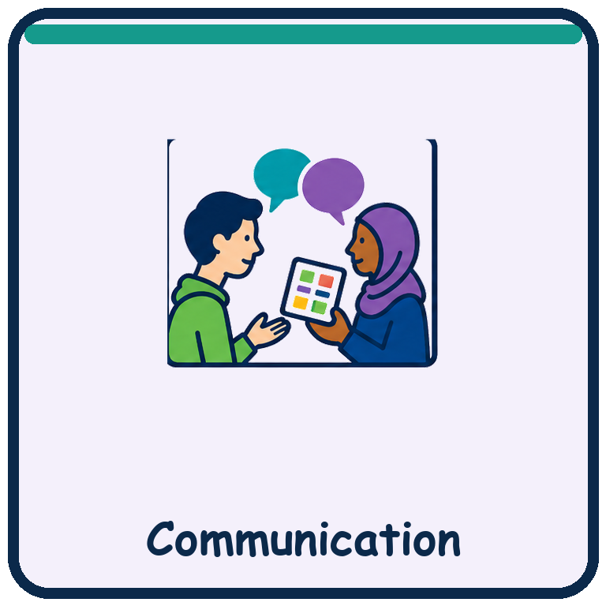 | 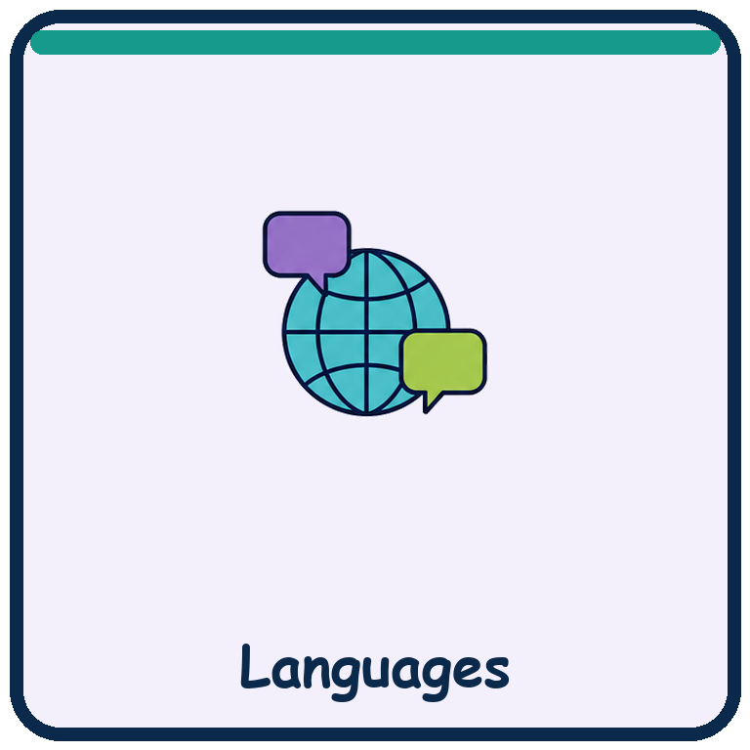 | 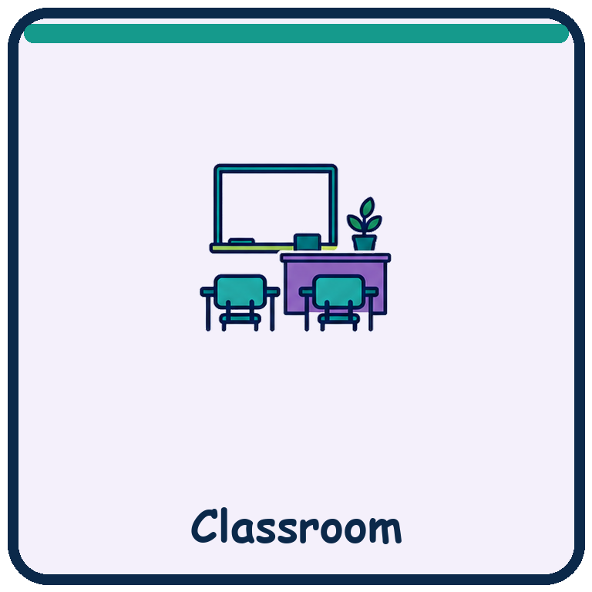 | 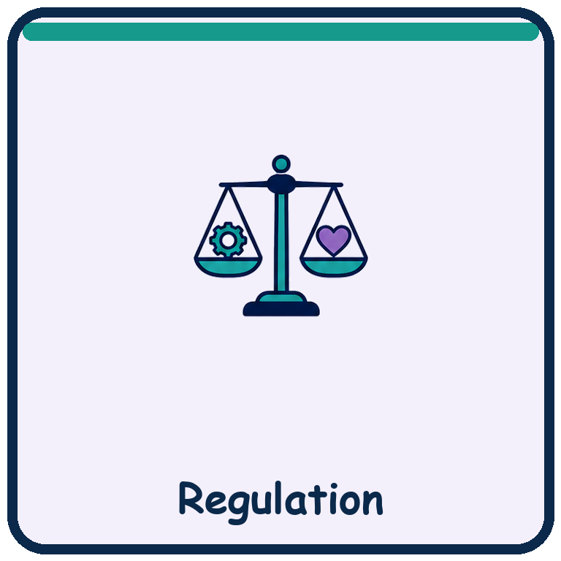

Purpose: Make classroom access, learner voice and IEP implementation easier for students who communicate in different ways or are still learning English.

School / program
________________________________________________________________________________

Teacher / team
________________________________________________________________________________

Use safely: These are classroom planning and communication supports, not an official IEP form or legal advice. Follow the student’s IEP, district procedures and communication system. Keep completed student records private.

Original My Journey pictograms created for this toolkit. Personalize symbols, photos, objects and AAC supports to the learner’s established communication system.

Communication Passport
Complete with the learner, family, bilingual staff and related-service providers.

 |  | 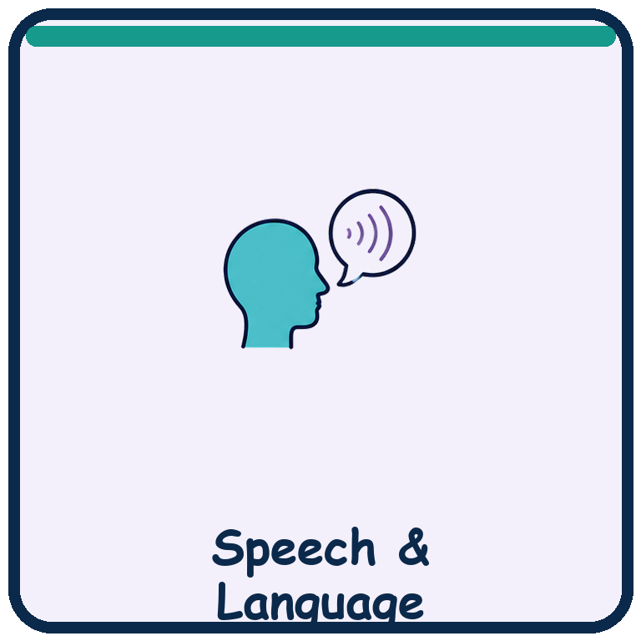 | 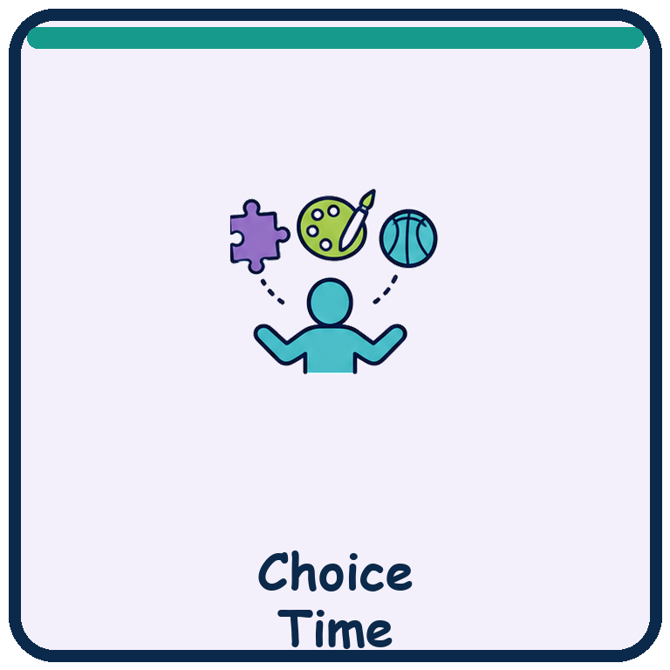

I communicate by… | Speech / AAC / signs / gestures / pointing / eye gaze / movement / behavior / objects / pictures / other:
My strongest language(s) | Home language(s), receptive language, expressive language and preferred words:
To offer a choice… | Number of choices, symbol size, field arrangement, partner position and wait time:
To check yes / no… | Describe the learner’s reliable yes, no, unsure and “not now” responses:
When I do not respond… | Pause, reduce language, model, re-present, change access method or return later:
Do not assume… | Silence, delayed response, echolalia, movement or behavior may not mean lack of understanding:

Words / symbols used at home Write the exact word, gesture or symbol and what it means.
________________________________________________________________________________
________________________________________________________________________________
________________________________________________________________________________

Team check: Can every adult recognize and honor the learner’s yes, no, stop, break, help and choice responses?

Learner Access Profile
Record what adults should do before asking the learner to perform.

 |  | 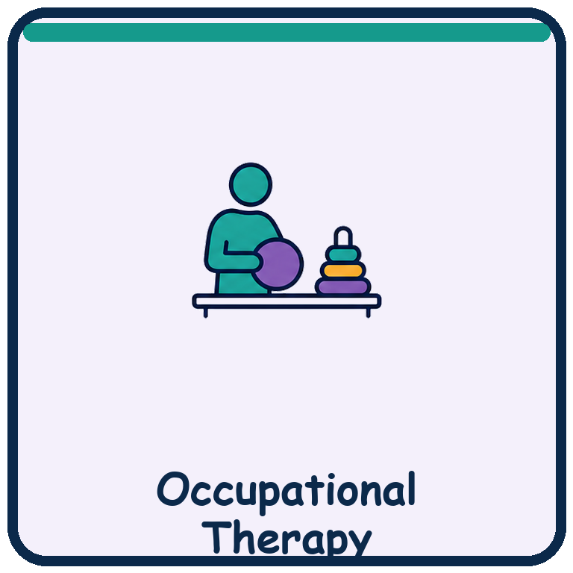 | 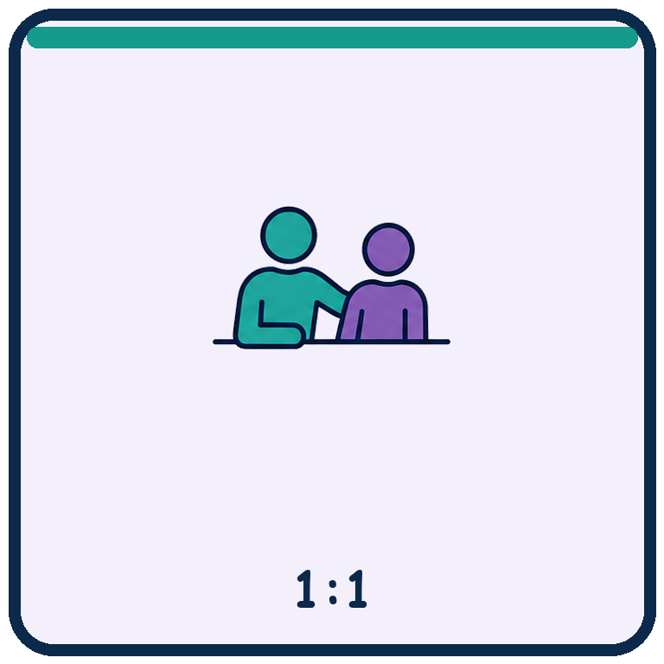

Strengths & interests | Preferred people, topics, objects, movement, sensory experiences and motivators:
Vision / hearing / motor | Positioning, contrast, symbol size, scanning, reach, eye gaze and access tools:
Attention & processing | Chunk size, wait time, repetition, previewing, first–then and predictable routines:
Sensory & regulation | Early signs, known triggers, helpful supports, recovery time and quiet locations:
Cultural & language access | Interpreter/translation needs, names, routines, examples and family preferences:
Dignity & autonomy | How the learner can refuse, pause, ask for privacy and make authentic choices:

Non-negotiable access supports Supports that must be available throughout the day.
________________________________________________________________________________
________________________________________________________________________________
________________________________________________________________________________

What success looks like today Use observable communication, participation and independence indicators.
________________________________________________________________________________
________________________________________________________________________________

I Need…
Show only the choices that are real and available. The learner may point, touch, look, sign, vocalize or use AAC.

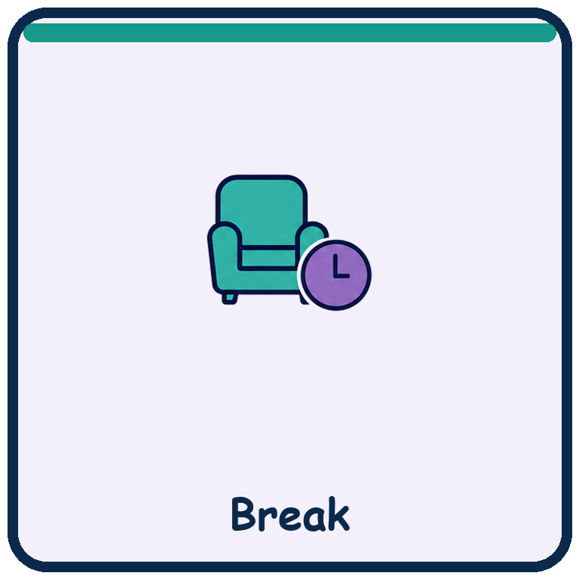  Home word: __________________ | 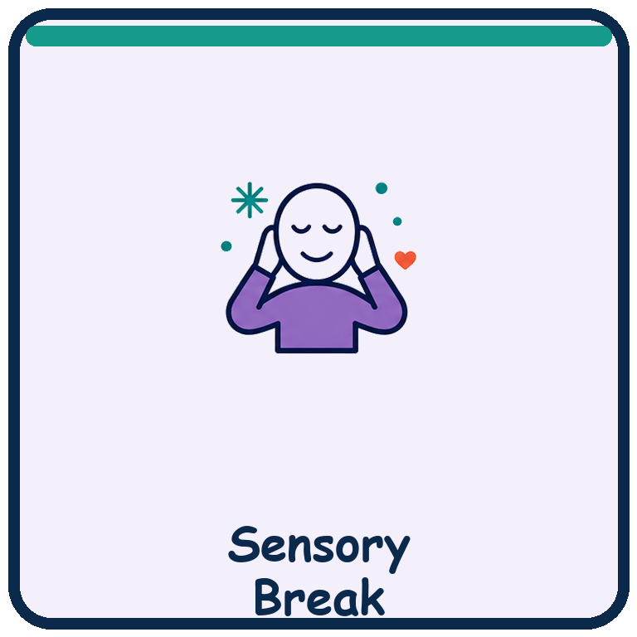  Home word: __________________ | 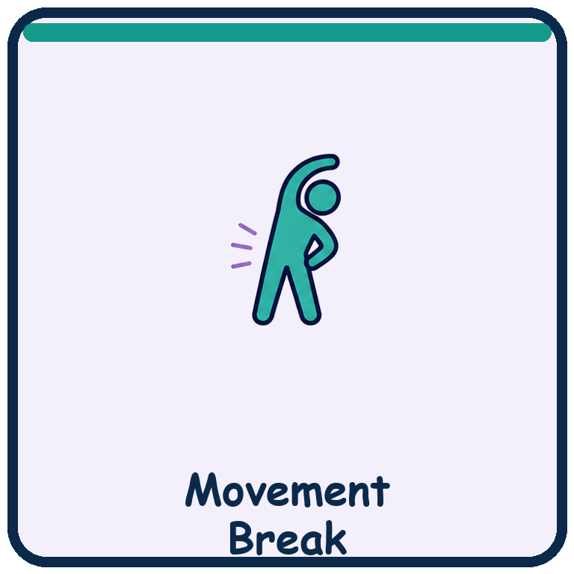  Home word: __________________
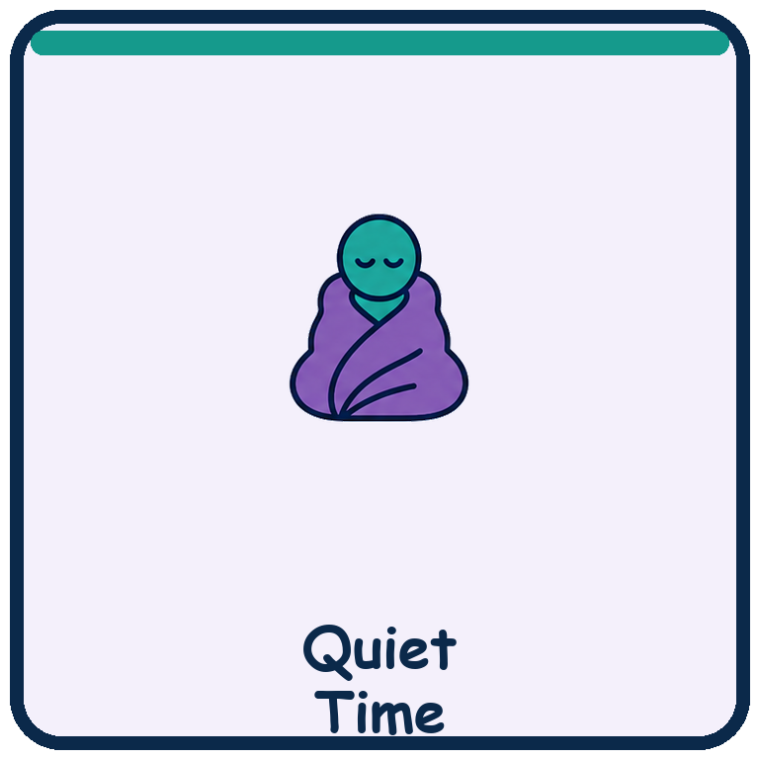  Home word: __________________ | 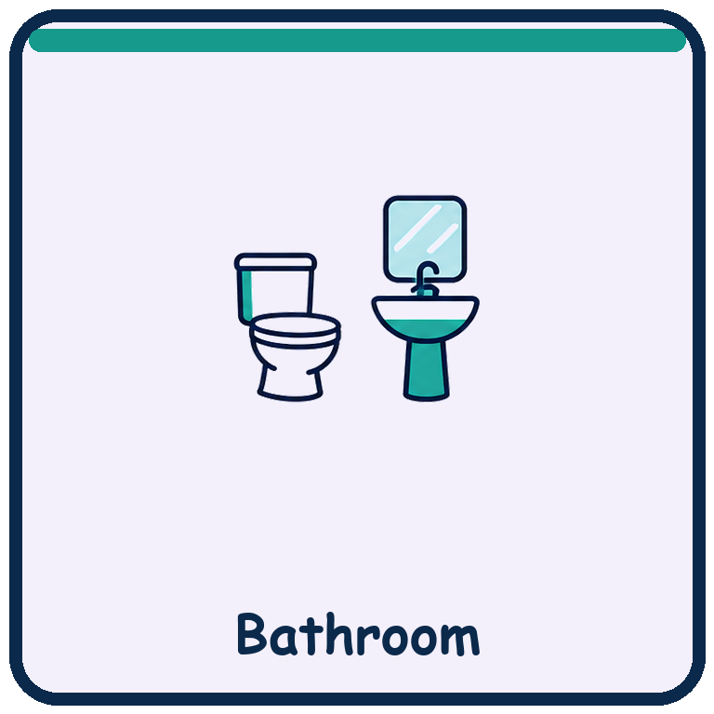  Home word: __________________ | 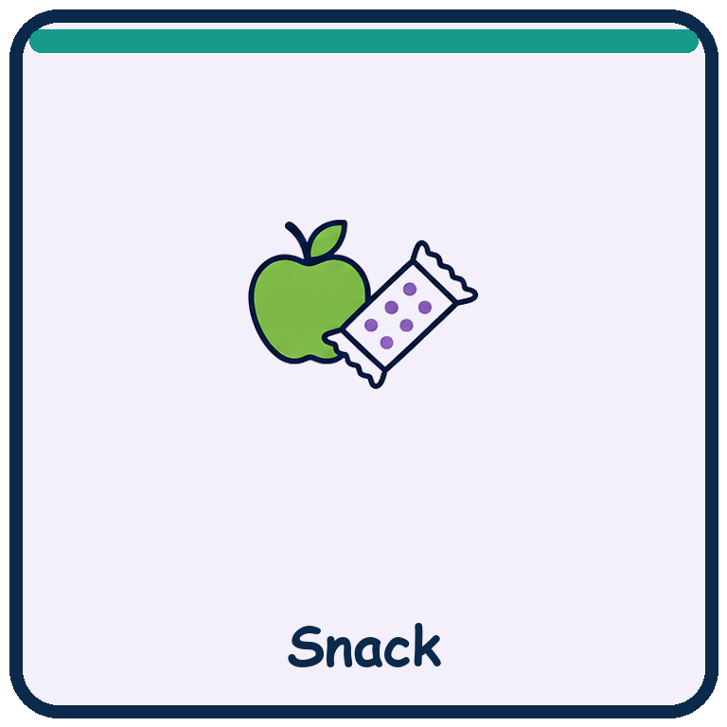  Home word: __________________

Adult response: Acknowledge the selection immediately. If a choice cannot happen now, say when it can happen and offer an honest alternative. Do not require speech.

My learner’s “help” symbol / response Insert the learner’s established communication symbol, AAC icon, object cue or photo.
________________________________________________________________________________
________________________________________________________________________________

My learner’s “stop / no / not now” response Describe exactly what adults should notice and honor.
________________________________________________________________________________
________________________________________________________________________________

My School Day
Use this board to preview, choose, answer “what next?” or show where the learner is going.

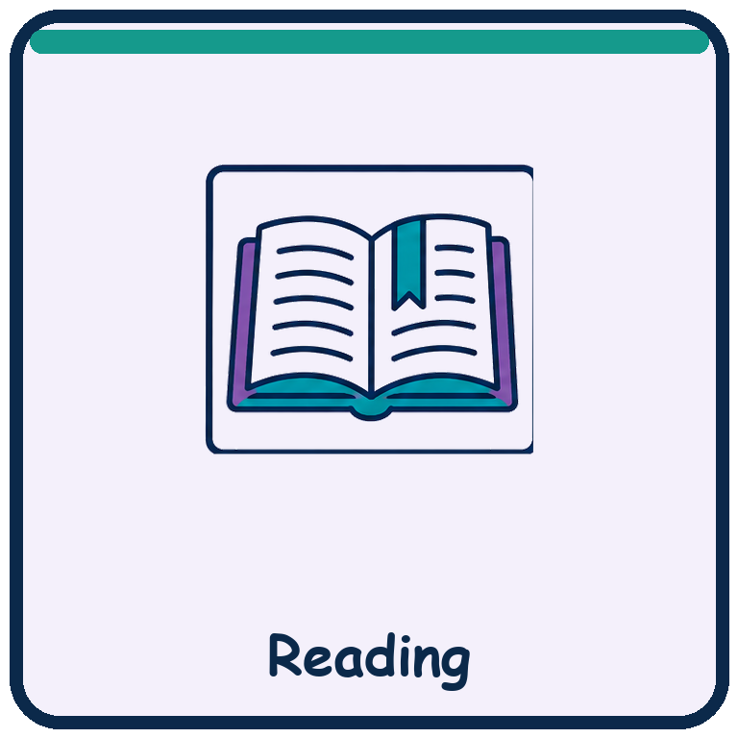  Home word: __________________ | 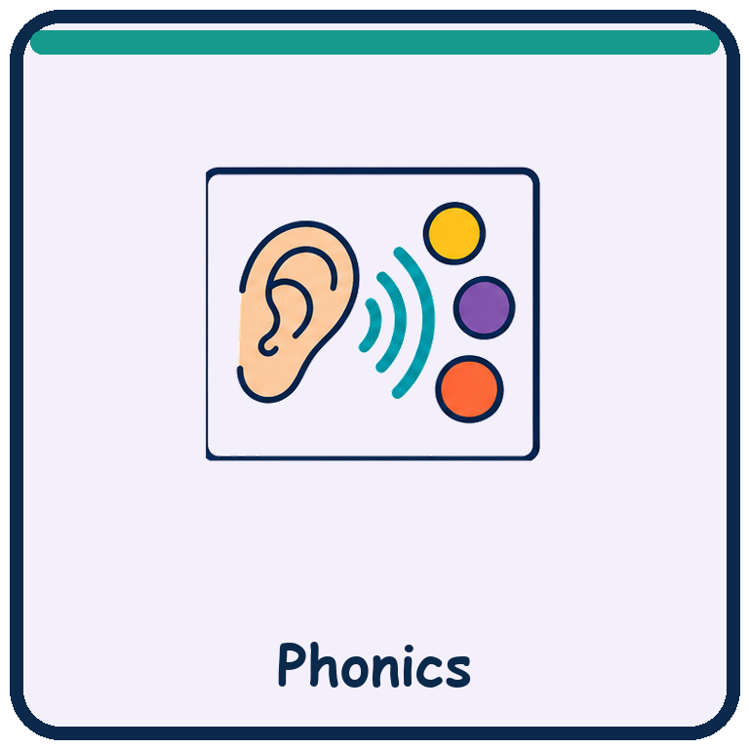  Home word: __________________ | 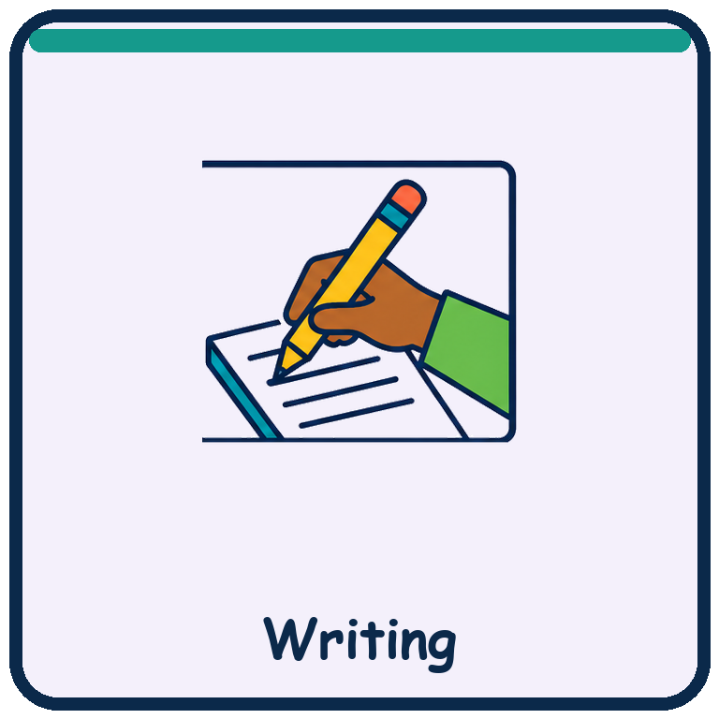  Home word: __________________ | 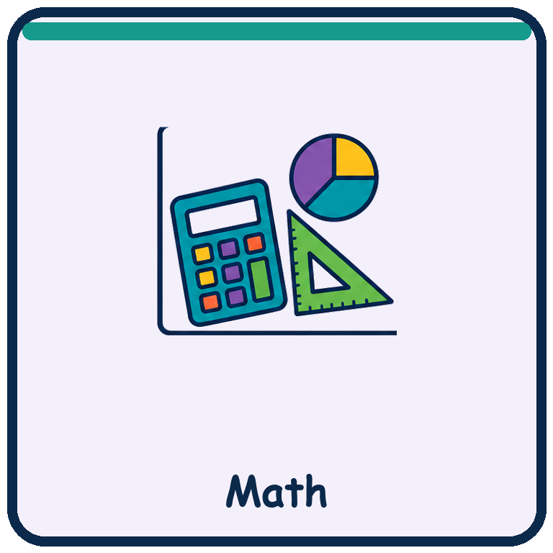  Home word: __________________
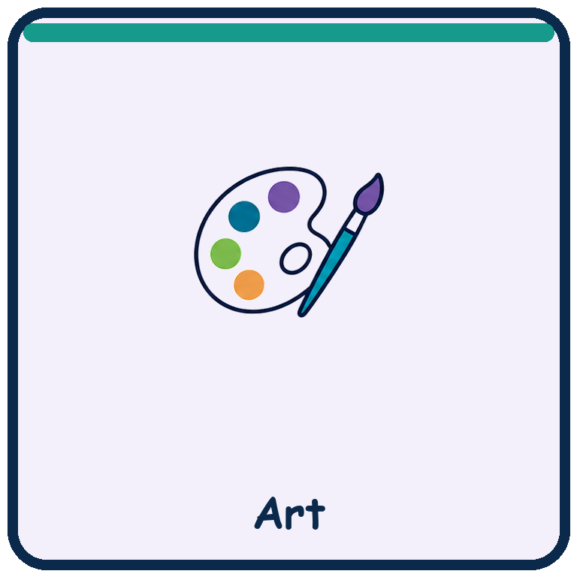  Home word: __________________ | 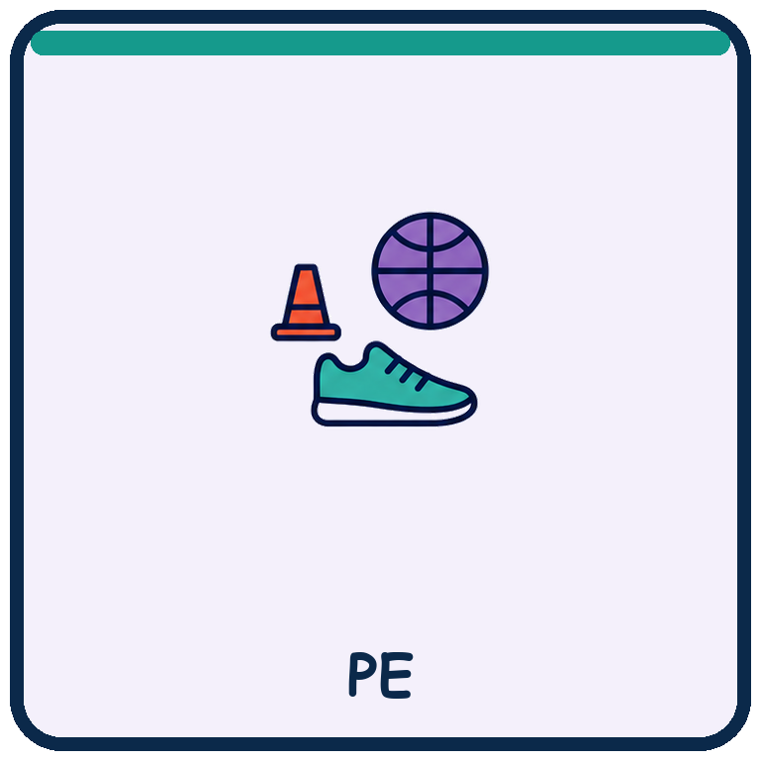  Home word: __________________ | 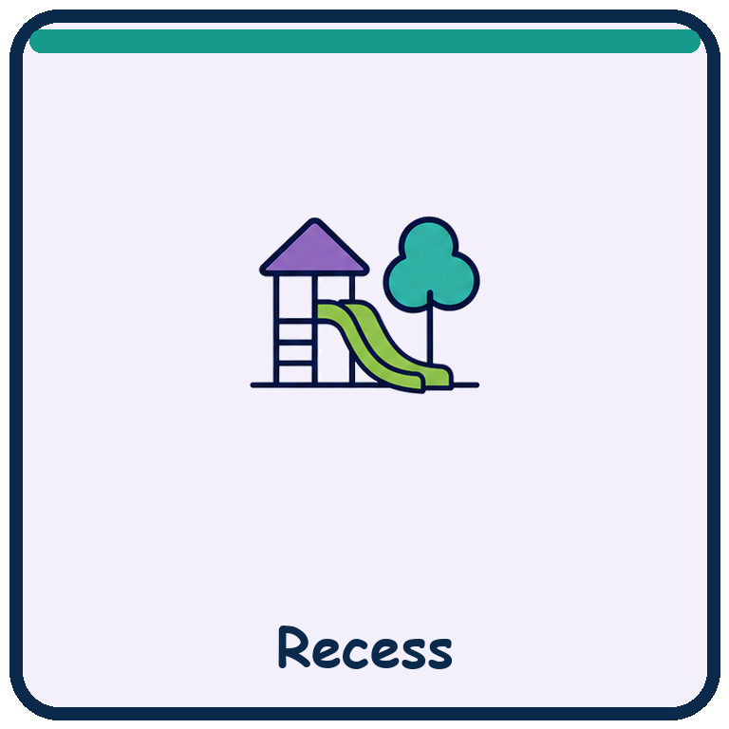  Home word: __________________ | 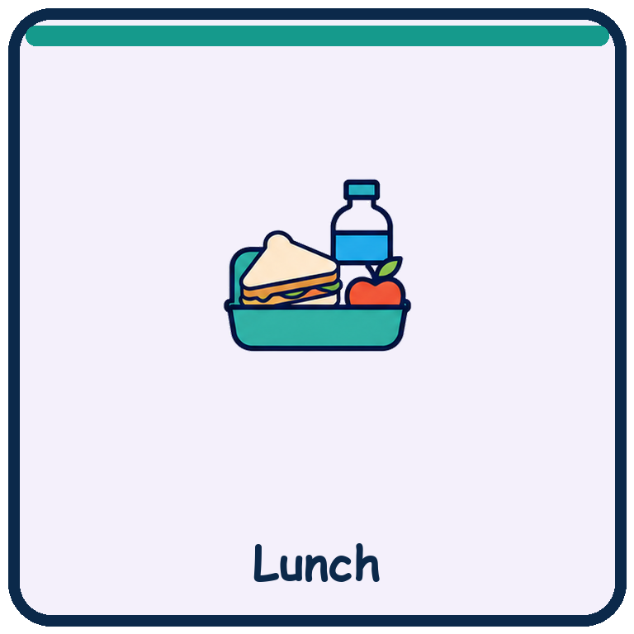  Home word: __________________

Now → Next NOW: ______________________________ NEXT: ______________________________
________________________________________________________________________________

Language access: Say the home-language word if known, point to the symbol, and allow extra processing time. Keep the spoken message short and consistent.

How I Show My Answer
Build a reliable response system before measuring knowledge.

 | 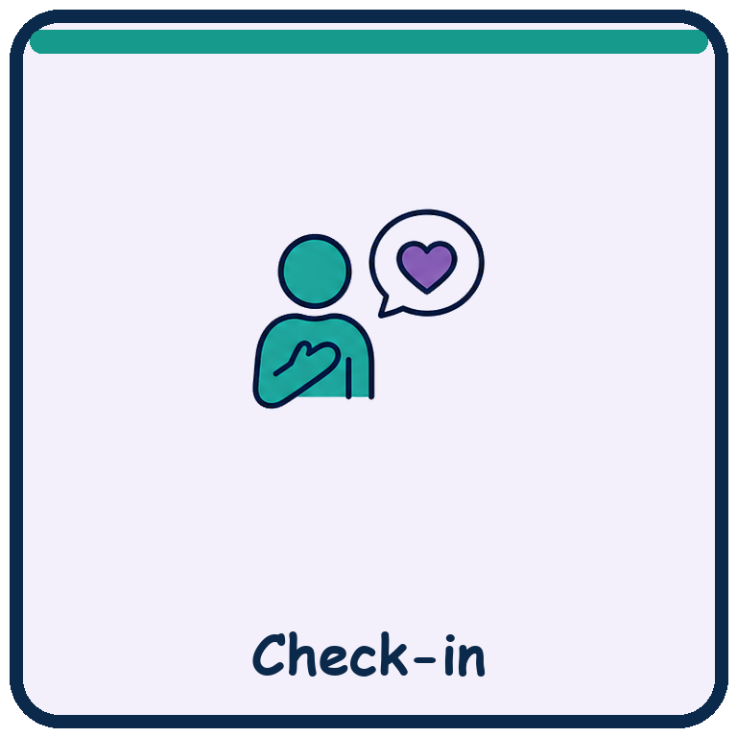 |  | 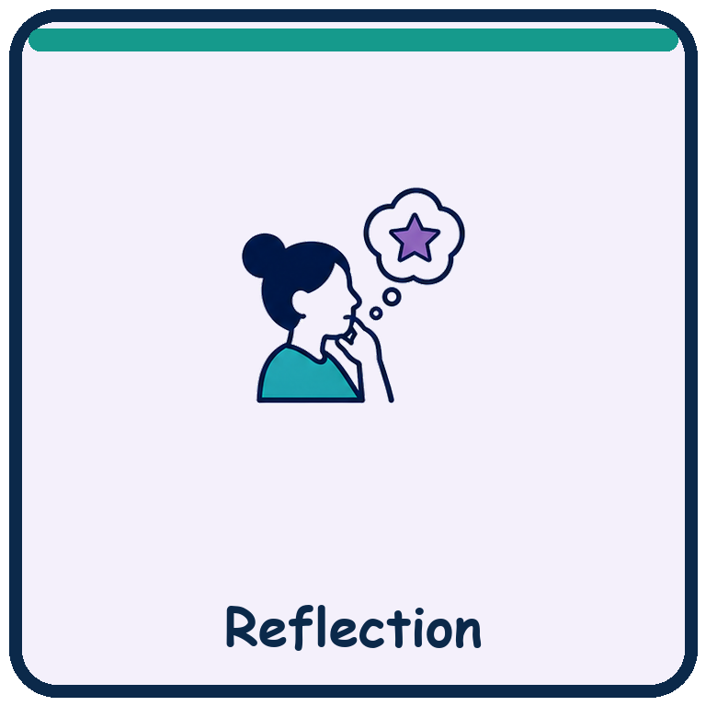

YES | Insert the learner’s established symbol or AAC response. Describe gesture, gaze, sound or action:
NO | Insert the learner’s established symbol or AAC response. Describe gesture, gaze, sound or action:
NOT SURE | How the learner indicates uncertainty, needs repetition or wants more time:
HELP | How the learner requests assistance and what level of help to offer first:
STOP / FINISHED | How the learner ends, refuses or asks to pause without penalty:
MY CHOICE | How choices are presented: field size, left/right placement, partner-assisted scan or eye gaze:

Partner directions Exact prompt, wait time, confirmation routine and what counts as a response.
________________________________________________________________________________
________________________________________________________________________________
________________________________________________________________________________

Assessment rule: Do not score expressive speech, English proficiency or motor speed when the target is knowledge in another area.

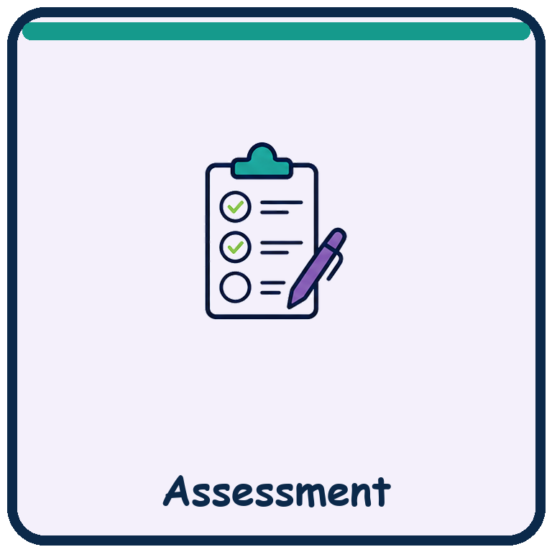 | Accommodation Implementation Record  Connect the written accommodation to a visible classroom routine.

IEP accommodation | Copy the exact wording from the current IEP:
Student need / barrier | What access barrier is this intended to reduce?
Materials ready | Symbols, AAC, visual schedule, adapted paper, seating, technology or sensory tools:
Adult action | What staff will do, when they will do it and what prompt language they will use:
Learner response | How the learner can accept, refuse, request or change the support:
Implementation evidence | Date, context, whether provided, student access and instructional next step:

Consistency check across settings Classroom / specials / lunch / recess / transportation / assessment / community:
________________________________________________________________________________
________________________________________________________________________________
________________________________________________________________________________

Important: An accommodation changes access, timing, response or presentation; it does not lower the learning target unless the IEP identifies a modification.

Symbol-Supported Lesson Planner
Plan one shared learning goal with multiple ways to access, respond and participate.

Learning target | What should learners understand or do? Write it in plain language:
Essential symbols | Which symbols, objects, photos or real materials will carry meaning?
Input | Model, demonstration, read-aloud, gesture, visuals, bilingual preview, audio or tactile access:
Response | Point, choose, match, sort, build, act, eye gaze, sign, AAC, speak, write or create:
Participation | Independent, partner, small group, adult-supported, movement-based or community setting:
Regulation | Breaks, sensory tools, reduced demand, predictable sequence and re-entry plan:

Three levels of the same task Entry access / developing independence / extending or generalizing:
________________________________________________________________________________
________________________________________________________________________________
________________________________________________________________________________
________________________________________________________________________________

Evidence to capture What will count, who records it and how language/motor demands are separated from the target?
________________________________________________________________________________
________________________________________________________________________________

IEP Goal-to-Activity Bridge
Turn a goal into meaningful, age-respectful practice across routines.

Goal / objective | Copy or summarize the measurable skill without changing the criterion:
Current baseline | What can the learner do now, under which conditions and with which supports?
Meaningful context | Where does this skill matter in school, home, community, relationships or future life?
Symbol / communication access | Vocabulary, field size, home-language support, AAC pathway and wait time:
Prompt plan | Independent → environmental cue → gesture → model → verbal/physical support, as appropriate:
Generalization plan | Change person, place, material, wording or time while maintaining access:

Practice ideas across grade levels Elementary-style entry point plus an age-respectful version for older learners with similar support needs.
________________________________________________________________________________
________________________________________________________________________________
________________________________________________________________________________
________________________________________________________________________________

Data rule Define a correct response and how prompts, refusals, breaks and communication repairs are recorded.
________________________________________________________________________________
________________________________________________________________________________

A–K–I–C–G Observation
A fast record of access, knowledge, independence, communication and generalization.

A — Access & engagement Which symbols, language supports, materials, positioning or regulation supports enabled participation?
________________________________________________________________________________
________________________________________________________________________________

K — Knowledge & quality What exact action, selection, creation or performance showed understanding?
________________________________________________________________________________
________________________________________________________________________________

I — Independence What prompts or partner actions were present? What was initiated independently?
________________________________________________________________________________
________________________________________________________________________________

C — Communication & agency What did the learner choose, refuse, request, repair, share or advocate for?
________________________________________________________________________________
________________________________________________________________________________

G — Generalization What changed from previous practice: person, place, material, wording or time?
________________________________________________________________________________
________________________________________________________________________________

Instructional decision Continue / change / explicitly teach / fade / test next:
________________________________________________________________________________
________________________________________________________________________________

Team Communication Map
Keep classroom, family, language and related-service supports aligned.

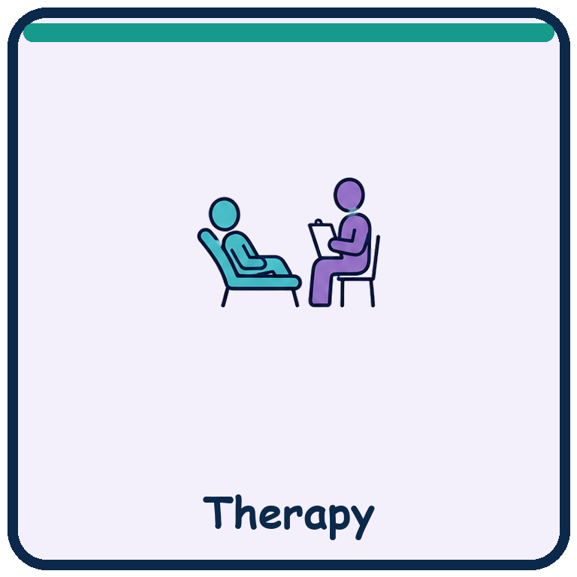

Learner voice | What the learner has chosen, refused, enjoyed, initiated or asked adults to understand:
Family knowledge | Home language, routines, cultural context, priorities and communication that works at home:
Teacher / paraprofessional | Where access succeeds or breaks down during real classroom routines:
SLP / AAC team | Vocabulary, symbol use, access method, modeling, partner training and device consistency:
OT / PT / health | Positioning, sensory, motor, fatigue, personal-care and equipment considerations:
Bilingual / interpreter support | How meaning will be checked without treating English acquisition as disability:

One shared priority for the next two weeks Observable, meaningful and realistic across settings.
________________________________________________________________________________
________________________________________________________________________________

Who will do what, where and by when?
________________________________________________________________________________
________________________________________________________________________________
________________________________________________________________________________

How and when we will ask the learner Include symbols/AAC, setting, communication partner and wait time.
________________________________________________________________________________
________________________________________________________________________________

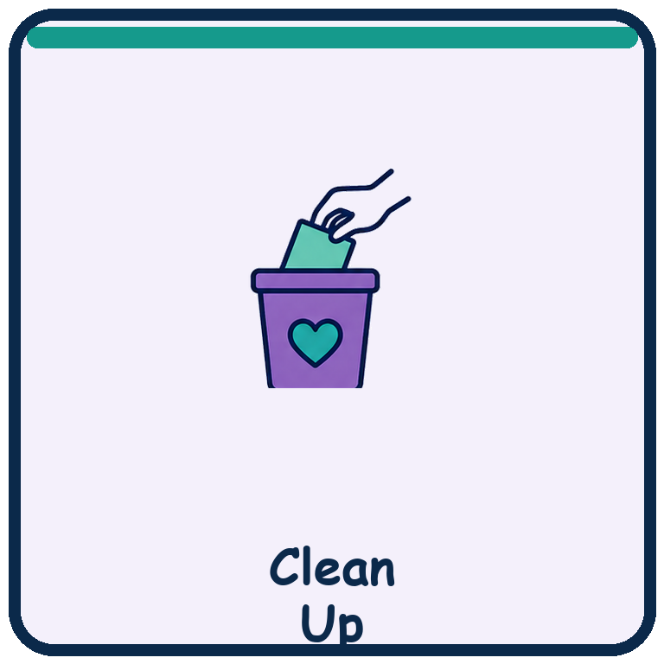 | Personalize Before Use  A short setup checklist for safe, consistent communication access.

☐ Confirm symbols match the learner’s established communication system.
☐ Replace generic choices with real choices available in that setting.
☐ Add home-language words with family/interpreter input; do not rely on automatic translation alone.
☐ Print symbols large enough for the learner’s vision, motor access and scanning field.
☐ Decide how the learner will point, touch, eye gaze, scan, sign, vocalize or use AAC.
☐ Teach all communication partners to wait, confirm and honor refusals.
☐ Keep activities age-respectful even when the learner’s communication level is emerging.
☐ Collect evidence about access—not only correctness—and adjust the supports.
Publish blank templates only. Do not upload completed student pages. Confirm that any third-party symbols, photos or AAC content you add may be shared with the intended audience.

Symbols or photos still needed Examples: yes, no, help, finished, specific people, rooms, foods, transport and preferred activities.
________________________________________________________________________________
________________________________________________________________________________
________________________________________________________________________________
________________________________________________________________________________

Original My Journey pictograms • Created for classroom and family use

